V1

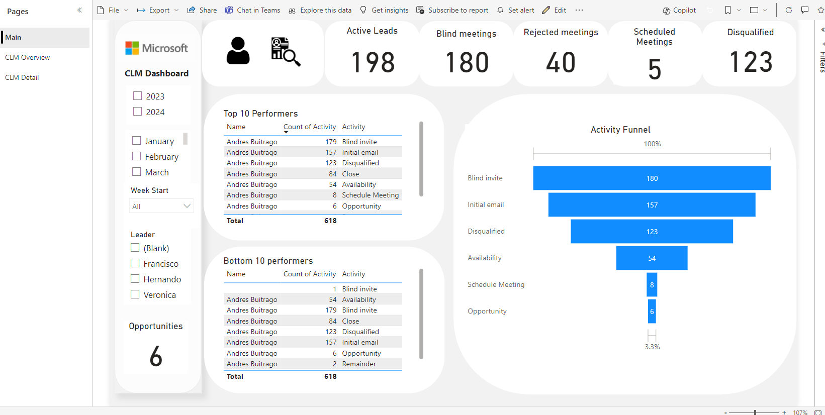

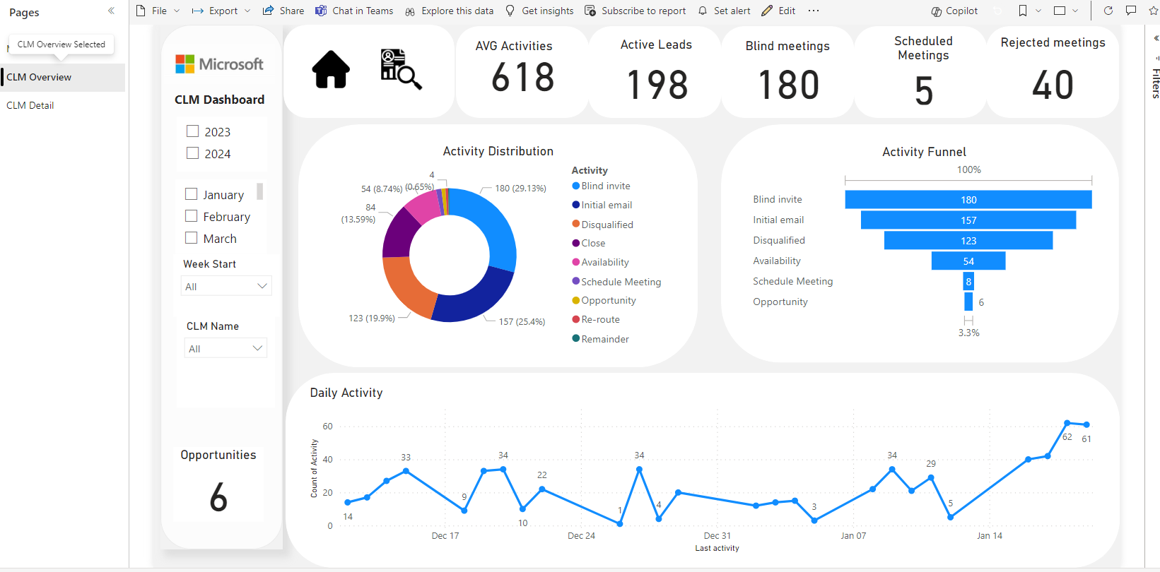

V2

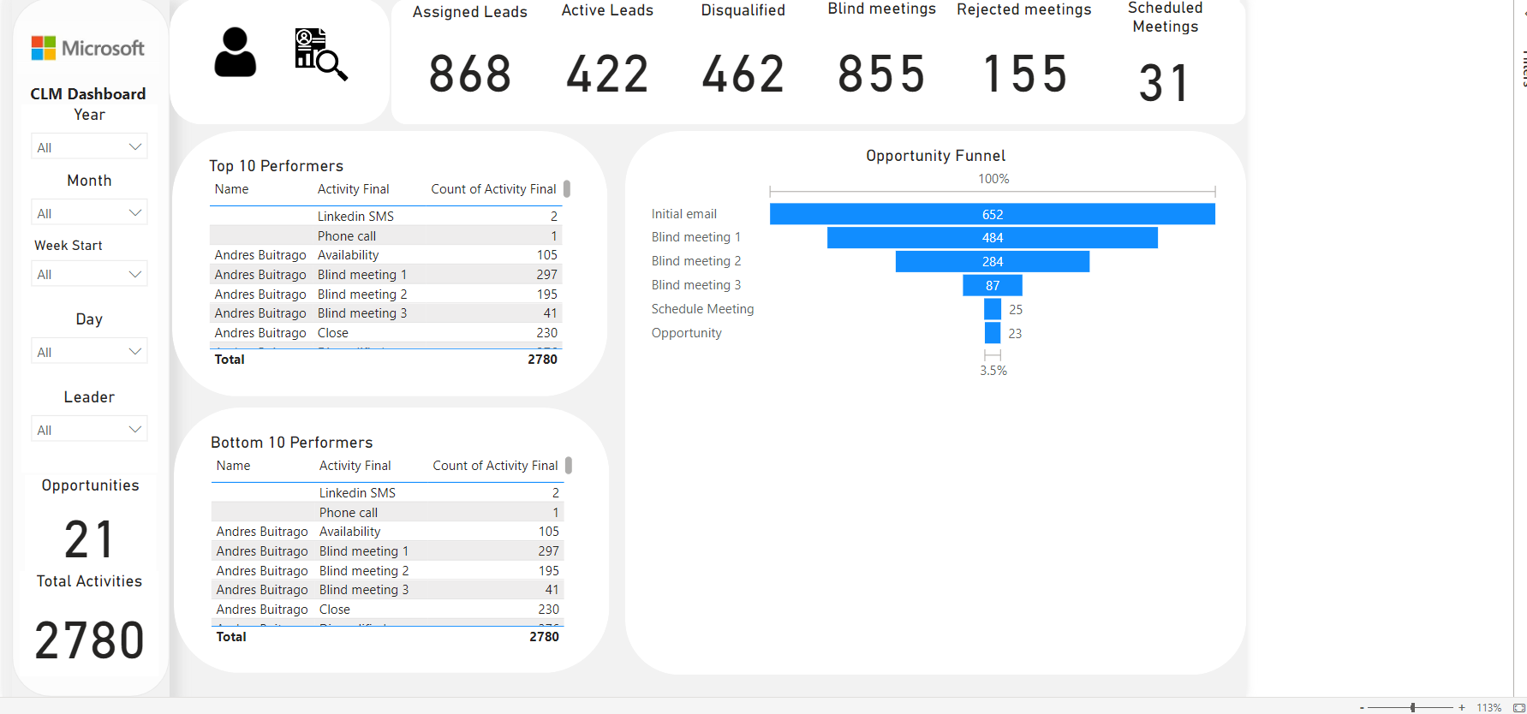

Change in data source

Move all trackers to a folder

Create a query in a single excel file to combine all trackers in one file

Create process for cleaning in power bi and/or python